**Gracious Germents**

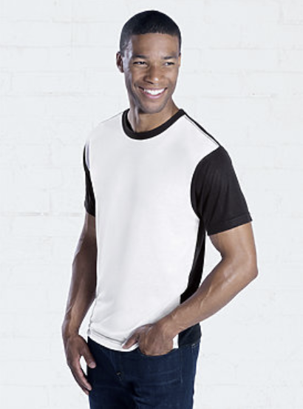

**DESCRIPTION:**

SubliVie™ Adult 100% Polyester Blackout Crew Neck Short Sleeve Sublimation Tee

Great for athletic uses, this SubliVie™ t-shirt, made with moisture wicking technology, was designed specifically for sublimation printing and produces superior results. The white front and black sleeves and back allows for an athletic color block look or for easier one sided sublimation.

Fabrication: 4.5 oz. 100% polyester moisture management jersey • Sewn with 100% polyester thread

Features: Contrast black ribbed collar • Shoulder-to-shoulder self-fabric back neck tape • Contrast black back and sleeves • Double needle sleeves and bottom hem • Side seam construction • EasyTear™ label

Care: Machine washable/ tumble dry low

Fit: Adult Unisex – True to Size

**ADDITIONAL INFORMATION**

Weight: 0.5 kg

Dimensions: 10 × 8 × 3 cm

Size: S, M, L, XL

Price: $30.00